**Procedures to execute Jmeter tests for LMS**

Requirement: (if you want to run on you own server)

Server – 2CPUs, at least 6GB, but 8GB Memory would be better.

Jmeter – Software

Directory Structures – I would create this to keep all analysis organized.

* Performance Scripts
* Performance Analysis
* Performance HTML

1. Download the latest Jmeter release
2. Jmeter can be open thru the .bat file or shell script.

* Location Jmeter installation folder /Bin
* Jmeter Bat. File
* Jmeter.sh
* If your system allows, Direct open - ApacheJMeter.jar file

1. There a 3 testing scripts combine to 1 Test scenario. You have an choice of either disabling other Test scenarios run individually or choose to run the Test Scenarios separately using the BAT files I created.

e.g. of the current test combine script(This test scenario includes the constant wait time so that test scenario AddDelUsers and APIEnrollment occurs during the GroupEnrollment execution process.

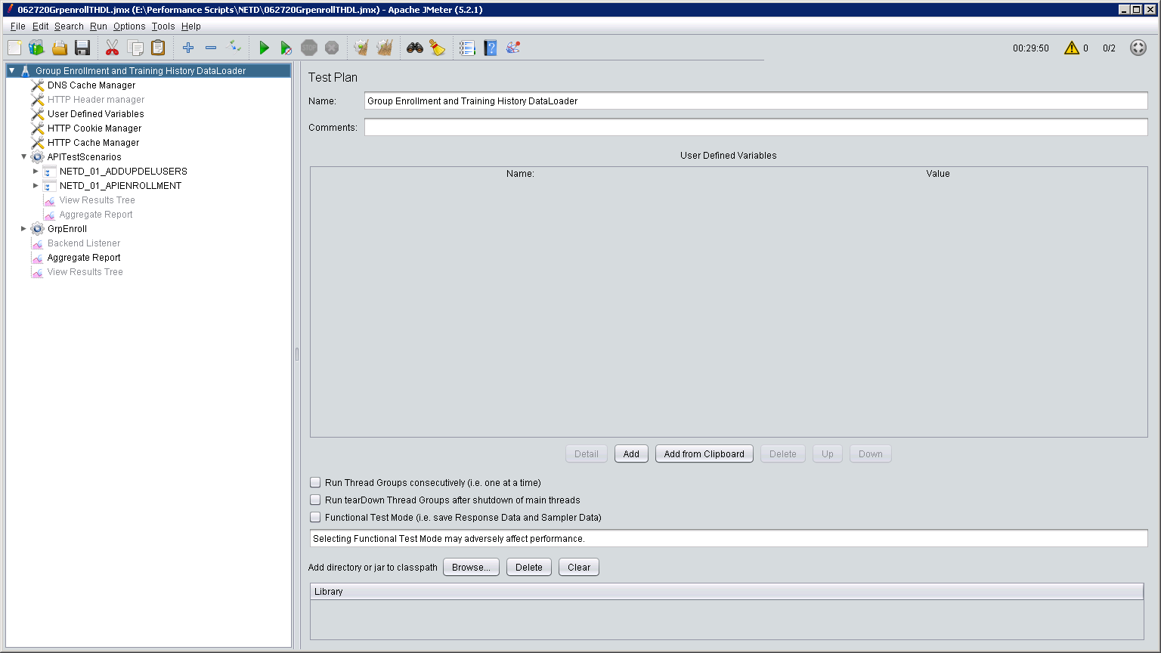

Here is the breakdown of all Test Scenarios:

**Test Script Add and Delete Users:**

I have created 2 CSV file: (same users)

* Add25LMSUsers.csv
* Del25LMSUsers.csv

**Format below:**

Action,UserID,Email,FamilyName,GivenName,Password,UserRole,,,,,

A,PTLMS1,PTLMS1@dummy.com,PT,LMS1,Pa55word1,SL,,,,,

A,PTLMS2,PTLMS2@dummy.com,PT,LMS2,Pa55word1,SL,,,,,

A,PTLMS3,PTLMS3@dummy.com,PT,LMS3,Pa55word1,SL,,,,,

A,PTLMS4,PTLMS4@dummy.com,PT,LMS4,Pa55word1,SL,,,,,

A,PTLMS5,PTLMS5@dummy.com,PT,LMS5,Pa55word1,SL,,,,,

A,PTLMS6,PTLMS6@dummy.com,PT,LMS6,Pa55word1,SL,,,,,

A,PTLMS7,PTLMS7@dummy.com,PT,LMS7,Pa55word1,SL,,,,,

A,PTLMS8,PTLMS8@dummy.com,PT,LMS8,Pa55word1,SL,,,,,

A,PTLMS9,PTLMS9@dummy.com,PT,LMS9,Pa55word1,SL,,,,,

A,PTLMS10,PTLMS10@dummy.com,PT,LMS10,Pa55word1,SL,,,,,

A,PTLMS11,PTLMS11@dummy.com,PT,LMS11,Pa55word1,SL,,,,,

A,PTLMS12,PTLMS12@dummy.com,PT,LMS12,Pa55word1,SL,,,,,

A,PTLMS13,PTLMS13@dummy.com,PT,LMS13,Pa55word1,SL,,,,,

A,PTLMS14,PTLMS14@dummy.com,PT,LMS14,Pa55word1,SL,,,,,

A,PTLMS15,PTLMS15@dummy.com,PT,LMS15,Pa55word1,SL,,,,,

A,PTLMS16,PTLMS16@dummy.com,PT,LMS16,Pa55word1,SL,,,,,

A,PTLMS17,PTLMS17@dummy.com,PT,LMS17,Pa55word1,SL,,,,,

A,PTLMS18,PTLMS18@dummy.com,PT,LMS18,Pa55word1,SL,,,,,

A,PTLMS19,PTLMS19@dummy.com,PT,LMS19,Pa55word1,SL,,,,,

A,PTLMS20,PTLMS20@dummy.com,PT,LMS20,Pa55word1,SL,,,,,

A,PTLMS21,PTLMS21@dummy.com,PT,LMS21,Pa55word1,SL,,,,,

A,PTLMS22,PTLMS22@dummy.com,PT,LMS22,Pa55word1,SL,,,,,

A,PTLMS23,PTLMS23@dummy.com,PT,LMS23,Pa55word1,SL,,,,,

A,PTLMS24,PTLMS24@dummy.com,PT,LMS24,Pa55word1,SL,,,,,

A,PTLMS25,PTLMS25@dummy.com,PT,LMS25,Pa55word1,SL,,,,,

Delete uses the same format just replace “A” with “D”

I have a CSV files that contains 3K if more is needed for testing. NOTE: I would probably use 2 different files to distinguish between Adding and Deleting.

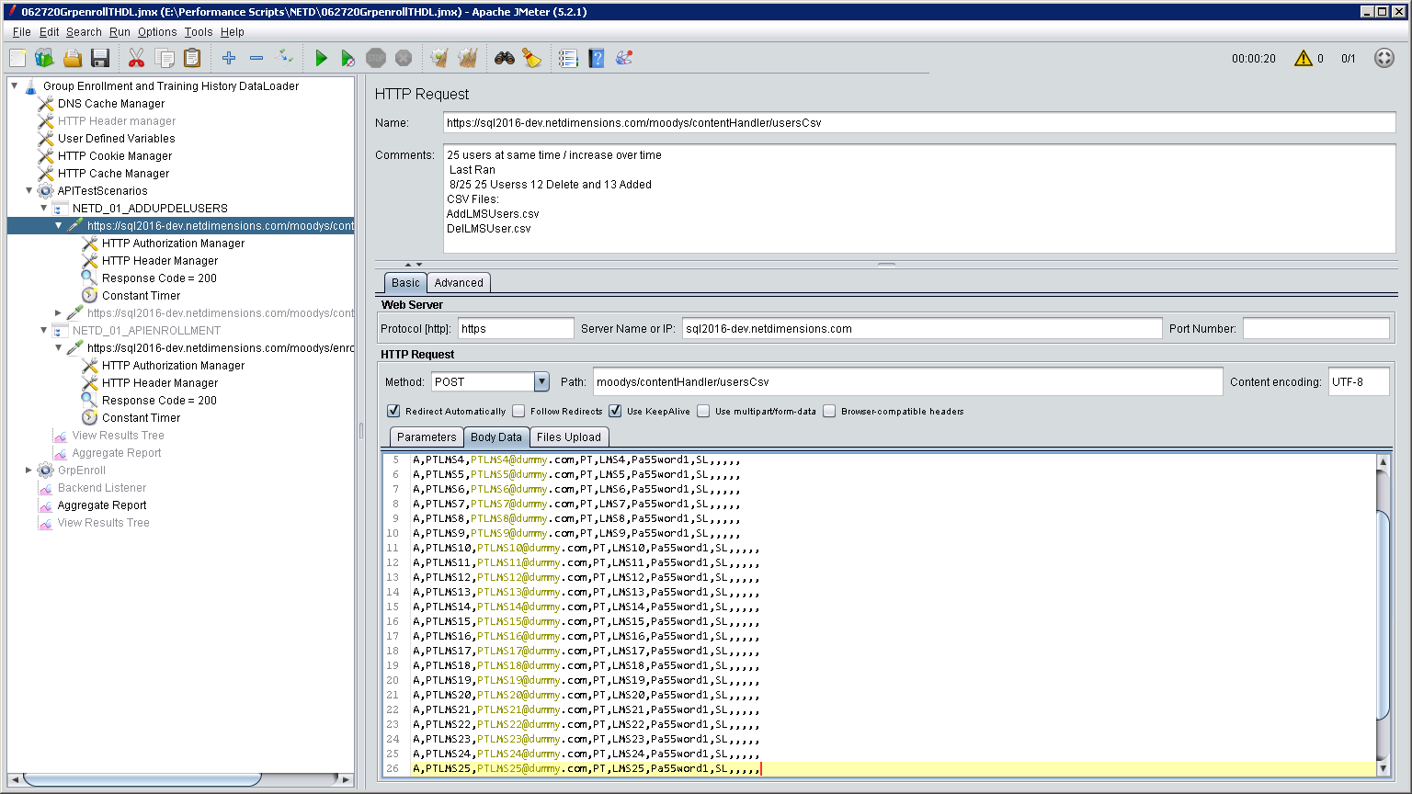

The full CSV contains 3K users. – 091420CreateAD3k.csv

**Test script Transfer of session – classes only**

I have created 2 separate CSV files: One that will switch users from Session 1 to 2, and another that will switch them back from Session 2 to 1.

* 091420Tran25S1toS2.csv (25 users transferring from Session 1 to Session 2)
* 091420Tran25S2toS1.csv (25 users transferring from Session 2 to Session 1)

091420Tran50S1toS2.csv – Currently, used in individual runs only (Contains 50 users)

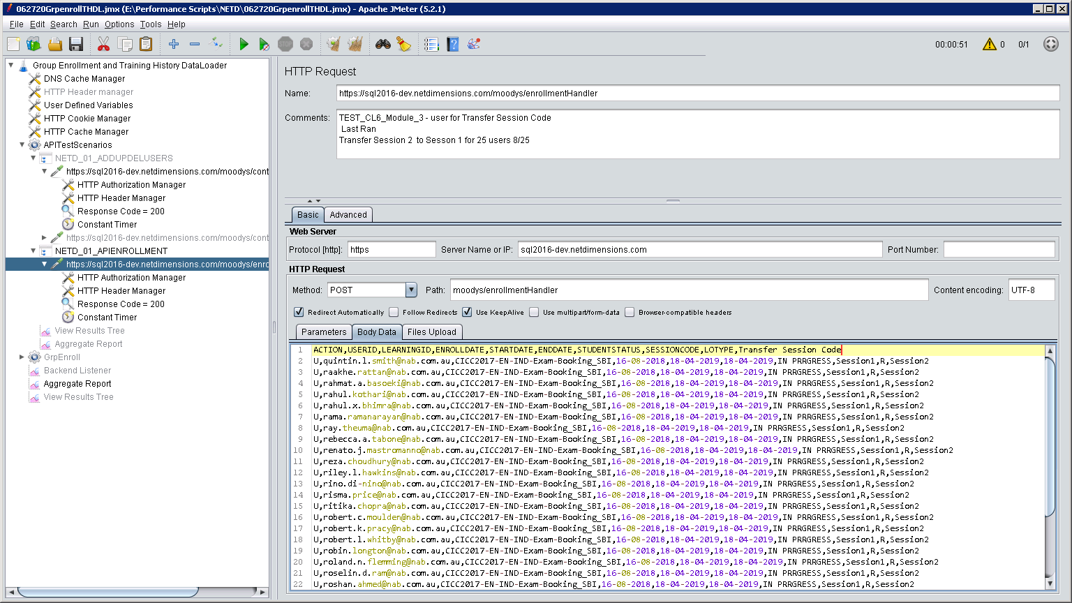

**Format below: - The only change would Session 1 to Session 2 and the reverse.**

ACTION,USERID,LEARNINGID,ENROLLDATE,STARTDATE,ENDDATE,STUDENTSTATUS,SESSIONCODE,LOTYPE,Transfer Session Code

U,quintin.l.smith@nab.com.au,CICC2017-EN-IND-Exam-Booking_SBI,16-08-2018,18-04-2019,18-04-2019,IN PRRGRESS,Session1,R,Session2

U,raakhe.rattan@nab.com.au,CICC2017-EN-IND-Exam-Booking_SBI,16-08-2018,18-04-2019,18-04-2019,IN PRRGRESS,Session1,R,Session2

U,rahmat.a.basoeki@nab.com.au,CICC2017-EN-IND-Exam-Booking_SBI,16-08-2018,18-04-2019,18-04-2019,IN PRRGRESS,Session1,R,Session2

U,rahul.kothari@nab.com.au,CICC2017-EN-IND-Exam-Booking_SBI,16-08-2018,18-04-2019,18-04-2019,IN PRRGRESS,Session1,R,Session2

U,rahul.x.bhimra@nab.com.au,CICC2017-EN-IND-Exam-Booking_SBI,16-08-2018,18-04-2019,18-04-2019,IN PRRGRESS,Session1,R,Session2

U,rama.ramanarayan@nab.com.au,CICC2017-EN-IND-Exam-Booking_SBI,16-08-2018,18-04-2019,18-04-2019,IN PRRGRESS,Session1,R,Session2

U,ray.theuma@nab.com.au,CICC2017-EN-IND-Exam-Booking_SBI,16-08-2018,18-04-2019,18-04-2019,IN PRRGRESS,Session1,R,Session2

U,rebecca.a.tabone@nab.com.au,CICC2017-EN-IND-Exam-Booking_SBI,16-08-2018,18-04-2019,18-04-2019,IN PRRGRESS,Session1,R,Session2

U,renato.j.mastromanno@nab.com.au,CICC2017-EN-IND-Exam-Booking_SBI,16-08-2018,18-04-2019,18-04-2019,IN PRRGRESS,Session1,R,Session2

U,reza.choudhury@nab.com.au,CICC2017-EN-IND-Exam-Booking_SBI,16-08-2018,18-04-2019,18-04-2019,IN PRRGRESS,Session1,R,Session2

U,riley.l.hawkins@nab.com.au,CICC2017-EN-IND-Exam-Booking_SBI,16-08-2018,18-04-2019,18-04-2019,IN PRRGRESS,Session1,R,Session2

U,rino.di-nino@nab.com.au,CICC2017-EN-IND-Exam-Booking_SBI,16-08-2018,18-04-2019,18-04-2019,IN PRRGRESS,Session1,R,Session2

U,risma.price@nab.com.au,CICC2017-EN-IND-Exam-Booking_SBI,16-08-2018,18-04-2019,18-04-2019,IN PRRGRESS,Session1,R,Session2

U,ritika.chopra@nab.com.au,CICC2017-EN-IND-Exam-Booking_SBI,16-08-2018,18-04-2019,18-04-2019,IN PRRGRESS,Session1,R,Session2

U,robert.c.moulden@nab.com.au,CICC2017-EN-IND-Exam-Booking_SBI,16-08-2018,18-04-2019,18-04-2019,IN PRRGRESS,Session1,R,Session2

U,robert.k.pracy@nab.com.au,CICC2017-EN-IND-Exam-Booking_SBI,16-08-2018,18-04-2019,18-04-2019,IN PRRGRESS,Session1,R,Session2

U,robert.l.whitby@nab.com.au,CICC2017-EN-IND-Exam-Booking_SBI,16-08-2018,18-04-2019,18-04-2019,IN PRRGRESS,Session1,R,Session2

U,robin.longton@nab.com.au,CICC2017-EN-IND-Exam-Booking_SBI,16-08-2018,18-04-2019,18-04-2019,IN PRRGRESS,Session1,R,Session2

U,roland.n.flemming@nab.com.au,CICC2017-EN-IND-Exam-Booking_SBI,16-08-2018,18-04-2019,18-04-2019,IN PRRGRESS,Session1,R,Session2

U,roselin.d.ram@nab.com.au,CICC2017-EN-IND-Exam-Booking_SBI,16-08-2018,18-04-2019,18-04-2019,IN PRRGRESS,Session1,R,Session2

U,roshan.ahmed@nab.com.au,CICC2017-EN-IND-Exam-Booking_SBI,16-08-2018,18-04-2019,18-04-2019,IN PRRGRESS,Session1,R,Session2

U,ross.k.gascoine@nab.com.au,CICC2017-EN-IND-Exam-Booking_SBI,16-08-2018,18-04-2019,18-04-2019,IN PRRGRESS,Session1,R,Session2

U,ross.w.mcgrath@nab.com.au,CICC2017-EN-IND-Exam-Booking_SBI,16-08-2018,18-04-2019,18-04-2019,IN PRRGRESS,Session1,R,Session2

U,ryan.a.brown@nab.com.au,CICC2017-EN-IND-Exam-Booking_SBI,16-08-2018,18-04-2019,18-04-2019,IN PRRGRESS,Session1,R,Session2

U,ryan.s.johnson@nab.com.au,CICC2017-EN-IND-Exam-Booking_SBI,16-08-2018,18-04-2019,18-04-2019,IN PRRGRESS,Session1,R,Session2

**Test Script Group Enrollment** (this script does not require any changes)

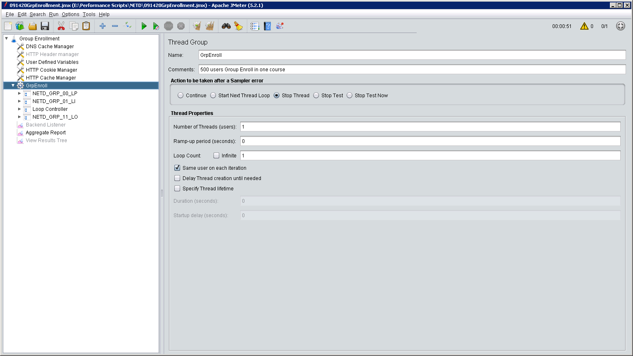

The Group Enrollment script is set to Group Enrolled 100 users. This has already been configured in the combine testing. I have also configured a Test script with 500 users too.

The snapshot below displays the Jmeter script. 0914GE500.jmx

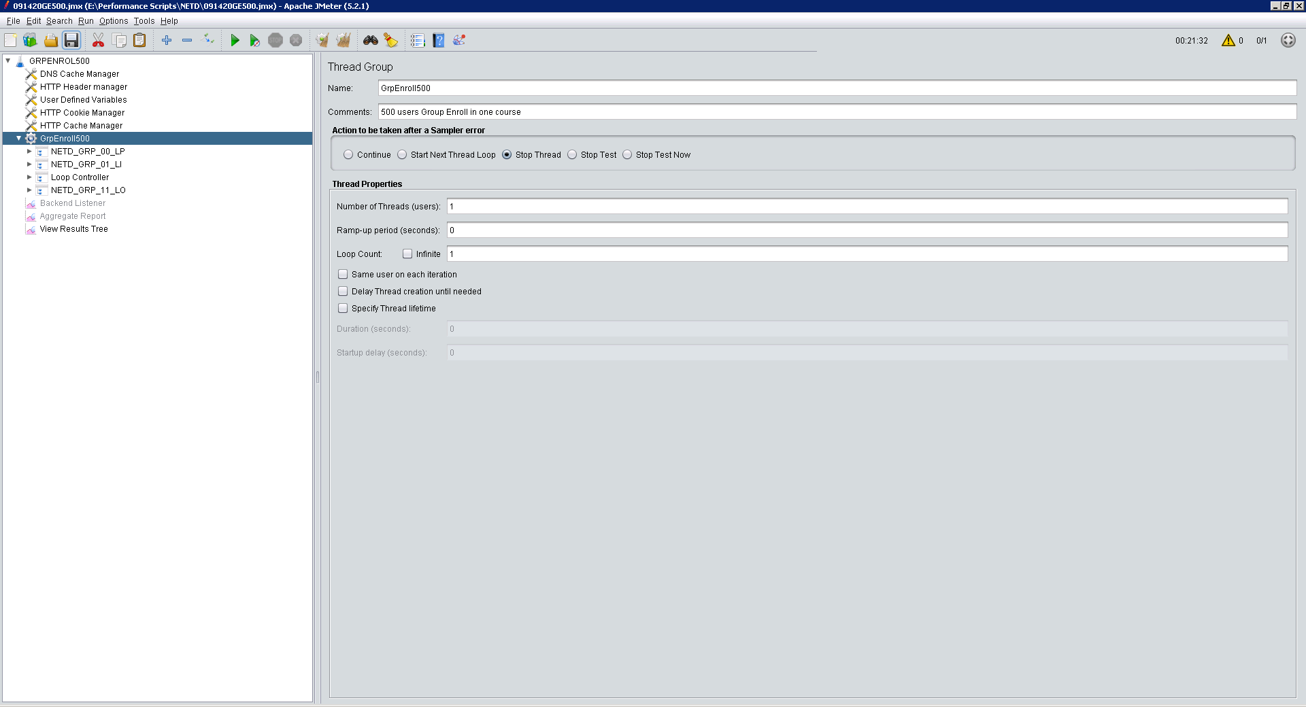

All scripts can be kicked off using BAT files, which require “NO INTERVENTION” all data required are within the files.

BAT FILE INFO: (You will have to be modified to accommodate your server setup)

@echo on

for /f "tokens=2 delims==" %%a in ('wmic OS Get localdatetime /value') do set "dt=%%a"

set "YY=%dt:~2,2%" & set "YYYY=%dt:~0,4%" & set "MM=%dt:~4,2%" & set "DD=%dt:~6,2%"

set "HH=%dt:~8,2%" & set "Min=%dt:~10,2%" & set "Sec=%dt:~12,2%"

set timestamp=%MM%%DD%%YY%-%HH%%Min%%Sec%

E: -- The drive my test swtiches to from the C: drive

CD E:\JMETER\apache-jmeter-5.2.1\bin – location of Jmeter installation

Start jmeter -n -t "E:\Performance Scripts\NETD\Scriptname.jmx" -l "E:\Performance Analysis\NETD\**TransionName**%timestamp%.csv" -e -o "E:\Performance HTML\NETD\**TransactionName**%timestamp%"

BAT FILES: (just click on Bat file to start test)

**Individual Test Scenario**

* 091420AddDel.bat
* 091420APIEnroll.bat
* 091520GrpEnroll.bat

**Combine Scenario**

* 062720GETHDL.bat